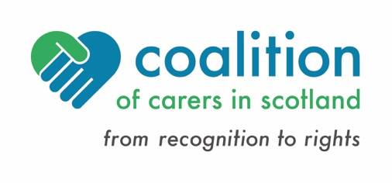
Eurocarers AGM 2022- Perspective from Scotland

- Ongoing situation for carers in Scotland
The majority of social care services were suspended at the beginning of the pandemic. Family members were expected to increase their caring role or take on a caring role for the first time to compensate for the gaps.
Services have been slow to restart and carers are struggling to access social care support and breaks from caring. The population of carers has increased during this time by 400,000
- Key policy gains and support for carers during the pandemic
- Online support: Grant funding was provided by the Scottish Government to enable local carers centres to move all support online (April 2020)
- Covid-19 testing: Carers were given priority status for testing, before it was made available to the general population (May 2020)
- Protective Equipment: Carers were provided with access to free PPE (May 2020)
- Vaccination: Carers received access to the vaccination programme, alongside people aged 16 to 65 in an at-risk group (March 2021)
- Breaks from Caring: Additional funding was delivered through local carers centres
- Winter Recovery Funding of £3million was made available through local carers centres, this included hardship funding for carers (January to March 2022)
- Key factors in driving change
- A well-established carers movement, supported by National Carer Organisations
- A network of local carers centres, who provided uninterrupted support to carers during the pandemic. Communications increased during this period with regular meetings and a Managers WhatsApp Group
- A Government Minister with responsibility for carers and a carers policy unit at the Scottish Government. In the first year of the pandemic weekly meetings were held between the policy unit and the National Carer Organisations
- Carer representation at government working groups, such as the Pandemic Recovery Group
- Policy and legislative developments – short term and longer term
Short Term
Living with Covid and Pandemic Recovery – A National Carers Strategy and Covid-19 recovery plan is currently in development and will be finalised by Autumn 2022
Longer Term
Disability and carer benefits are being transferred from the UK government to Scotland by 2023, followed by a review of the carers benefit (Carers Allowance will become Carers Assistance Payment)
An independent review of adult social care reported in February 2021. New legislation will be introduced by the June 2022, to re-design the system and changing the way we view social care
Proposals include:
- A human rights-based approach to social care
- Reform of assessment processes and eligibility criteria
- Development of a National Care Service, moving away from local standards and systems, towards a more consistent national model
- A right to breaks from caring for carers
- A fair workforce, with better terms and conditions for social care workers
- Emerging Trends and Risks
Challenges
- Carers are still living with Covid, many feel more isolated and unrecognised since restrictions have eased
- Some social care services, including breaks from caring, will not re-open, certainly in the short to medium term
- The health and social care workforce has been affected (also by Brexit!) and there is a severe workforce shortage
- The pandemic will leave a legacy of poor physical and mental health for many carers
- There has been an Impact on carers employment, with 9% of carers giving up work to care
- The rising cost of living will have a disproportionate impact on carers
- While reform is welcomed and Scotland is learning from the last 2 years, the current reform programme may be over ambitious
Emerging Trends
- Improved recognition of carers and their contribution as “equal partners in care” alongside that of the health and social care workforce
- Advancing a rights based approach to carer support with the development of a legal right to breaks from caring
- More flexible approach to self-directed support, including the employment of relatives
- Emergence of a blended approach to carer support, combining personal support with digital forms of communication. This enables more carers to participate in self-help, training and peer events, and in campaigning
- A greater realisation of the importance of social care and the need to invest in it
- An emerging understanding of the specific impacts of cost of living rises on carers and disabled people and the need to find ways to mitigate this

Claire Cairns, Coalition of Carers in Scotland, June 2022
Email: coalition@carersnet.org

Carers Week Research Report, 2020
State of Caring in Scotland, 2019
Carers UK, State of Caring report 2021

